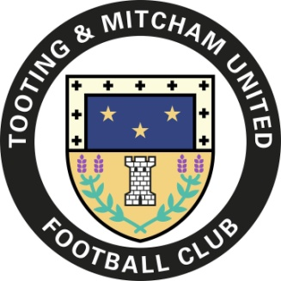
2023/24 100 Club Draw
By signing up for the 100 Club you will be helping the club raise extra funds for the 2023/24 season. From just £20 you can be entered into 8 monthly draws to win cash prizes of £50 and £30 plus a chance to win the bumper £250 Christmas and End of Season draws.

£20 will buy you one number, £50 buys 3 numbers and £90 gets you a bargain 6 numbers. You can pay up front by cheque, cash or by bank transfer.

If you are paying by cheque or through a bank transfer, please complete the form below and either hand it to me (or another club official) on a match day, at a club event or email a copy to tmufc100@gmail.com .
Numbers will be confirmed once payment is received in the 100 Club’s account - Sort Code 40-20-09 Act No 21608517. Account name: Tooting and Mitcham United FC Members

If you prefer to pay by cash - can you please complete the form and hand it and the cash to me (or another club official) on a match day or at a club event.

Good Luck

Graham Newsom
TMUFC 100 Club Promoter

I wish to join the TMUFC 100 Club 2023/24 and purchase (tick as appropriate):
□ 1 number - £20
□ 3 numbers - £50
□ 6 numbers - £90

- I enclose a cheque for £ …..……. made payable to ‘Tooting & Mitcham Utd FC 100 Club’
- I have made a bank transfer for £ …………
- I enclose cash £ ……….

Name: ___________________________________________________________________
Address: ___________________________________________________________________
Email Address: ___________________________________________________________________
Phone Number: ___________________________________________________________________

